**ACS 2913 – SOFTWARE REQUIREMENTS ANALYSIS AND DESIGN**

ASSIGNMENT 2

*DAMILARE ALESHINLOYE: 3099949*

*AVISHEK RAJ: 3107155*

*ANUOLUWAPO OYAFUNKE: 3092896*

1(a).

|  |  |  |
| --- | --- | --- |
| **Use case name** | **Actors** | **Brief Use Case Description** |
| Add to cart | Customer | User/actor enters name of product, and the system outputs product. “add to cart” option is then selected to add product to cart |
| Checkout cart | Customer | User/actor selects checkout option and fills out information form, then the system does calculation and returns the total bill with shipping and tax added. Customer then pays. |
| Ship out product | Shipping personnel | Shipping personnel retrieves product and looks up available carrier. System returns available carrier info to be contacted and product is handed over |
| Check availability | Warehouse personnel | This allows the warehouse personnel to check the availability of products and update stock or update on the system that the product is out of stock |
| Update profile information | Customer | This allows customers with an account to update their profile information like name, date of birth, shipping address, etc |

1(b).



2(a).

|  |  |
| --- | --- |
| **Identified noun** | **Notes on including noun as thing to store** |
| Management | We know who they are. No need to store. |
| Marketing | We know who they are. No need to store. |
| Merchandising | We know who they are. No need to store. |
| Product Availability | Indication on whether product is available. Need to store |
| Customer | A key element. Must be stored. |
| Color | Piece of info about a product. No need to store. |
| Credit Card Information | Part of an order or part of customer information? Research. |
| Inventory Update | New data after processing. Need to store. |
| Catalog | Needs to be constantly updated for customer use. Will be included |
| Accounting | We know who they are. No need to store |
| Carrier Availability | Track record of available carriers. Must be stored and kept updated |
| Cart Storage | Need to have items displayed in a cart |
| Product feedback | Important to get feedback. Include |
| Order Item | Is it the same as cart item? Research. |

(b) Final list of things to be stored

* Product availability
* Customer
* Credit card information
* Inventory update
* Catalog
* Carrier availability
* Cart storage
* Order Item
* Order/ order transaction
* Product Feedback

3. **Domain Model Class Diagram**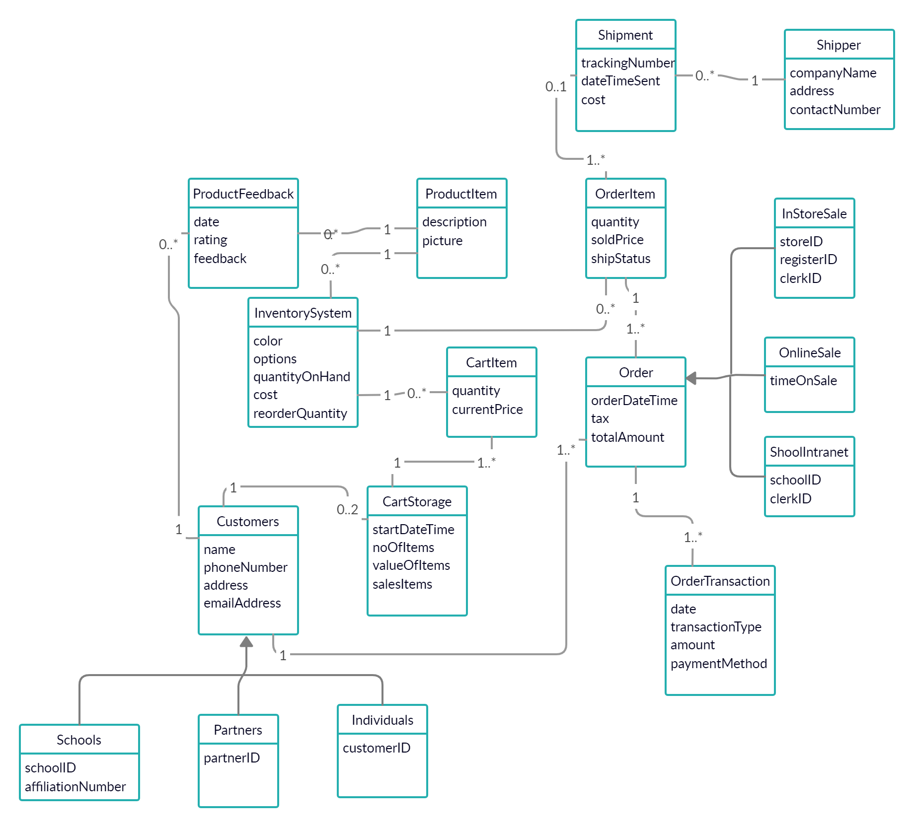

4. State Machine Diagrams

**Order**

|  |  |
| --- | --- |
| **State** | **Transition causing exit** |
| Open | itemOrdered |
| Ready to Ship | carrierFound |
| Package Order | orderPackaged |
| About to be shipped | shipOrder |
| Shipped | No exit transition defined |



**ProductAvailability**

|  |  |
| --- | --- |
| **State** | **Transition** |
| Normal stock | updateInventory |
| found | restock |
| not found | restock |
| On order | itemArrives |
| Not an order | orderItem |



**cartItem**

|  |  |
| --- | --- |
| **State** | **Transition** |
| Empty | productAdded |
| Cart Storage | cancel or productDelete or proceed |
| Invoice | finish or cancel |
| Checkout | paid |

